1. **Screenshots**
   1. **Screen 1:** Inquiry Records Search

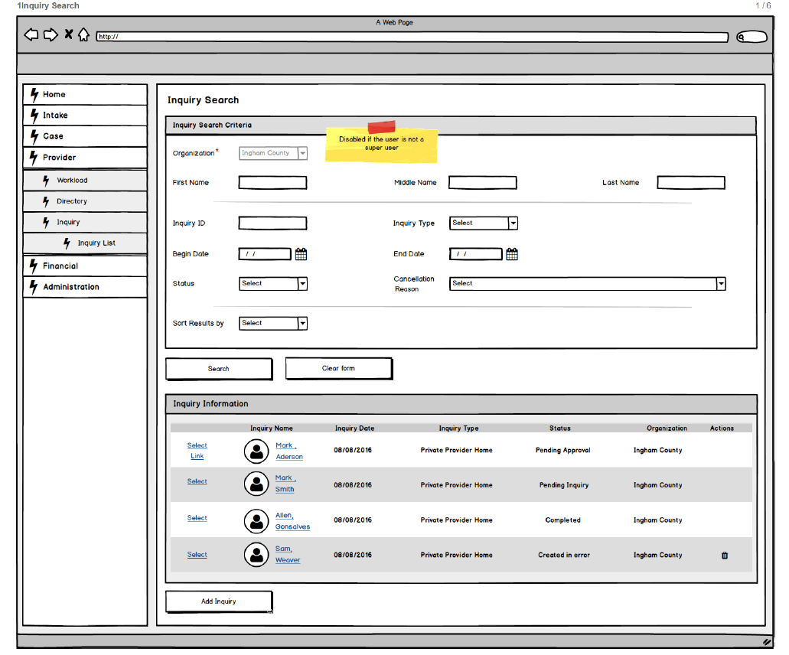

Figure 1 – List/Filter Provider Inquiry

* + 1. **Screen Fields**

| **Class.Attribute Name** | **Display Name** | **Type** | **Align** | **Size** | **Read Only** | **Calculation** | **Edit Mask** | **To Be UI Validation** |
| --- | --- | --- | --- | --- | --- | --- | --- | --- |
| N/A | Inquiry Search Criteria |  |  | N/A |  |  |  |  |
| ProviderInquiry.agencyId | Organization | Dropdown List |  | 100 | T | Use Agency Name based on Agency ID |  | User selected.  Default is based on the Organization to which the user belongs. |
| Person.lastName | Name (Last, First, Middle)  *See mockup | Text field | Left | 35 | F |  |  | User entered.  Not required. |
| Person.middleName | Name (Last, First, Middle)  *See mockup | Text field | Left | 25 | F |  |  | User entered.  Not required. |
| Person.firstName | Name (Last, First, Middle)  *See mockup | Text field |  | 35 | F |  |  | User entered.  Not required. |
| ProviderInquiry.inquiryId | Inquiry Id | Text field |  | 22 | F |  |  | User entered.  Not required. |
| ProviderInquiry.inquiryTypeCode | Inquiry Type | Dropdown List |  | 30 | F | **Domain Code:** InquiryType |  | User selected.  Not required. |
| N/A | N/A | Varchar2 |  | 30 |  | **Domain Code:** InquirySubType |  |  |
| ProviderInquiry.inquiryDate | Begin Date | Date field |  | 10 | F |  | MM/DD/YYYY | User entered.  Not required. |
| ProviderInquiry.noContactDate | End Date | Date field |  | 10 | F |  | MM/DD/YYYY | User entered.  Not required. |
| ProviderInquiry.decisionCode | Status | Dropdown List |  | 30 | F | **Domain Code:** InquiryStatus |  | User selected.  Not required. |
| ProviderInquiry.decisionReasonText | Cancellation Reason | Dropdown List |  | 1000 | F | **Domain Code:** InquiryCancelReason |  | User selected.  Not required. |
| N/A | Sort Results By |  |  | 30 | F | **Domain Code:** InquirySort |  | User selected.  Not required.  **Sort order is alpha**  **Add option to sort by ascending and descending Inquiry Date or Organization** |
| N/A | Inquiry Information | Group Frame |  | N/A |  |  |  |  |
| Person.lastName,Person.firstName,Person.middleName | Inquiry Name | Display text |  | 100 | T | Use Person.lastName,Person.firstName,Person.middleName where roleId is Inquirer1 | Last + “, “ + First + “ “ + Middle | System derived. |
| ProviderInquiry.inquiryDate | Inquiry Date | Display text |  | 10 | T |  | MM/DD/YYYY | System derived. |
| ProviderInquiry.inquiryTypeCode | Inquiry Type | Display text |  | 30 | T |  |  | System derived. |
| N/A | N/A | Display text |  | 30 | T |  |  |  |
| ProviderInquiry.decisionCode | Status | Varchar2 |  | 30 | T |  |  | System derived. |
| ProviderInquiry.agencyId | Organization | Number |  | 100 | T | Use Agency Name based on Agency ID |  | System derived. |

* + 1. **Action Buttons/Hyperlinks**

| **Label** | **Type** | **On Click Action/Navigation** |
| --- | --- | --- |
| Select | Hyperlink | Navigate to the Provider Home Inquiry for the selected Inquiry record with the first tab (S02) in focus. |
| Link | Hyperlink | Navigates to Potential Match screen (RM03). |
| Delete | Icon | Deletes the selected inquiry. Only available to the Inquiry Supervisor with a Status of Duplicate or Created in Error. |
| Add Inquiry | Button | Navigate to the Edit/View Inquiry screen (S02) as a new record. |
| Search | Button | Search will displayed the respective records in the ‘Inquiry Information’ grid which has been satisfied by the ‘Search Criteria’ |
| Clear form | Button | Clears all text from associated text field. |
| Name | Hyperlink | Navigates the user to the Person Overview page |

**2. Story**

As an Inquiry Worker, I want to maintain view existing inquiry records so that I can determine the need for inquiry next steps.

**3.1 Points to Note**

N/A

**3.2 Demo Steps**

1. Login to the USFN application with the following credentials

Username: samweaver

Any Password works.

1. The My Organizer is displayed after successful login.
2. Click on the provider tab.
3. Click on the Inquiry which will navigate to Inquiry list page.

**4. Acceptance criteria**

**4.1 Screen 1 Acceptance criteria**

|  |  |  |  |
| --- | --- | --- | --- |
| # | Requirement | Execution Event | Status |
| 1. 1 | If the user accessing the screen is attached to DHS Central Office, the Inquiry List will have filter criteria that defaults to all Inquiries that are either Pending Inquiry, or Pending Approval. The Inquiry List will initially be populated based on these search criteria. The sort order is alpha order of Inquiry Name within Pending Approval, followed by alpha of Inquiry Name within Pending Inquiry, followed by alpha of inquiry name along with completed, followed by alpha of inquiry name along with cancelled, Followed by alpha of inquiry name along with created in error. | Screen Open |  |
| 1. 2 | When the worker enters a value in the Provider Inquiry ID search field, all other fields are ignored and any information previously entered is removed. | Clicking on ‘search’ Button |  |
|  | The Delete icon is only displayed to users with a role of Inquiry Supervisor for Inquiries that have a Status of Created in Error. | Screen open or refresh |  |
|  | The Link hyperlink only appears for Provider Home Inquiry records that have a Status of Pending Approval. | Screen open and search. |  |